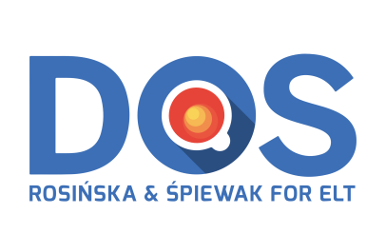 | 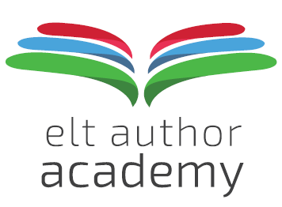

Application form
2018/2019

The following information is collected to facilitate the application process for DOS-ELTea ELT AUTHOR ACADEMY 2.0.

By submitting the data below, you give your consent to have your personal information processed and stored by DOS-ELTea s.c. M. Rosińska, G. Śpiewak. This includes in particular your agreeing to be contacted by DOS-ELTea s.c. via e-mail, mobile phone and social media, as appropriate.

DOS-ELTea s.c. shall make every effort to protect your data and will not make it available to any third party under any circumstances.

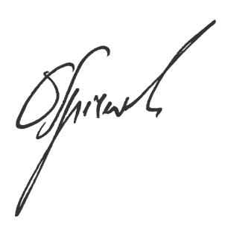
___________________________________ ___________________________________
DOS-ELTea your signature

- YOUR BASIC DATA
Name
Year of birth
Permanent address (incl. postcode)*
Mobile phone number:
e-mail
Facebook name/ nick?
Other social media (LinkedIn ? Google+ ?)
ID number
(seria i nr dowodu osob. lub paszportu)*
Will you need an invoice? If so, provide all info here | (Company )name:  NIP:  City:  Street:

* necessary for drafting the contract

- YOUR EDUCATIONAL HISTORY
BA: when, which university?
MA: when, which university?
Other degrees, diplomas, certificates?
In-service training programmes completed?
Any other relevant info?

- YOUR ELT JOB HISTORY
Current employer
Current position
Total EFL experience: how many years?
Past EFL experience (teaching or other): institutions, professional roles?
Please provide details.
Any foreign language materials development experience so-far? Please provide details.

Any other relevant info?

D. YOUR REASONS FOR APPLYING
Please explain briefly why you have decided to apply

- HOW DID YOU LEARN ABOUT ELT Author Academy?
Please tick ALL sources of info | e-mail from DOS-ELTea?
 | e-mail from The Teacher?
 | e-mail from Szukaj-Lektora?
 | advert in The Teacher?
 | IATEFL PL conference?
 | www.e-dos.org ?
 | DOS-ELTea Facebook page?
 | phone call from DOS-ELTea?
 | through a colleague?
 | direct contact with Marta and/or Grzegorz?
Any other sources?? If so, please list.

